**REACT**

**1.ReactJS-HOL**

**Home.js**

import React from 'react';

function Home() {

return <h2>Welcome to the Home page of Student Management Portal</h2>;

}

export default Home;

**about.js**

import React from 'react';

function About() {

return <h2>Welcome to the About page of the Student Management Portal</h2>;

}

export default About;

**contanct.js**

import React from 'react';

function Contact() {

return <h2>Welcome to the Contact page of the Student Management Portal</h2>;

}

export default Contact;

**App.js**

import React from 'react';

import Home from './Components/Home';

import About from './Components/About';

import Contact from './Components/Contact';

function App() {

return (

<div className="App">

<Home />

<About />

<Contact />

</div>

);

}

export default App;

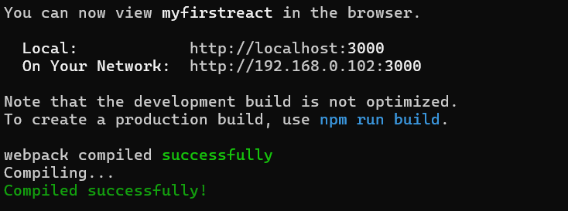

**2.ReactJS-HOL**

**Home.js**

import React from 'react';

function Home() {

return <h2>Welcome to the Home page of Student Management Portal</h2>;

}

export default Home;

**about.js**

import React from 'react';

function About() {

return <h2>Welcome to the About page of the Student Management Portal</h2>;

}

export default About

**contact.js**

import React from 'react';

function Contact() {

return <h2>Welcome to the Contact page of the Student Management Portal</h2>;

}

export default Contact;

**App.js**

import React from 'react';

import './App.css';

import Home from './Components/Home';

import About from './Components/About';

import Contact from './Components/Contact';

function App() {

return (

<div className="App">

<Home />

<About />

<Contact />

</div>

);

}

export default App;

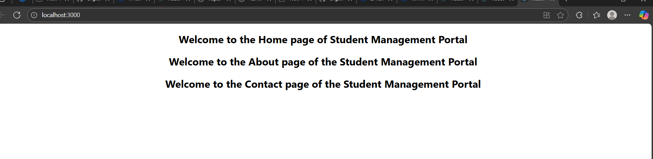

**3.ReactJS-HOL**

**calculatorScore.js**

import React from 'react';

import '../Stylesheets/mystyle.css';

function CalculateScore() {

const name = "Raji";

const school = "XYZ School";

const total = 450;

const goal = 500;

const average = (total / goal) * 100;

return (

<div className="score-card">

<h2>Score Calculator</h2>

<p><strong>Name:</strong> {name}</p>

<p><strong>School:</strong> {school}</p>

<p><strong>Total:</strong> {total}</p>

<p><strong>Goal:</strong> {goal}</p>

<p><strong>Average:</strong> {average.toFixed(2)}%</p>

</div>

);

}

export default CalculateScore;

**mysytle.css**

.score-card {

background-color: #f9f9f9;

padding: 20px;

margin: 30px;

border: 1px solid #ccc;

border-radius: 10px;

width: 300px;

font-family: Arial, sans-serif;

}

**App.js**

import React from 'react';

import './App.css';

import CalculateScore from './Components/CalculateScore';

function App() {

return (

<div className="App">

<CalculateScore />

</div>

);

}

export default App;

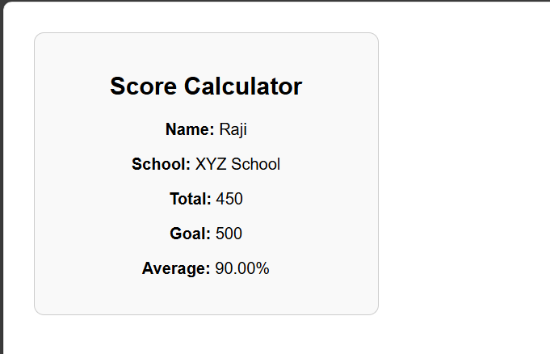

**4.ReactJS-HOL**

**Post.js**

import React from 'react';

class Post extends React.Component {

render() {

return (

<div>

<h3>{this.props.title}</h3>

<p>{this.props.body}</p>

</div>

);

}

}

export default Post;

**posts.js**

import React from 'react';

import Post from './Post';

class Posts extends React.Component {

constructor(props) {

super(props);

this.state = {

posts: [],

hasError: false,

};

}

loadPosts() {

fetch('https://jsonplaceholder.typicode.com/posts')

.then(response => response.json())

.then(data => this.setState({ posts: data }))

.catch(error => {

console.error("Error loading posts:", error);

this.setState({ hasError: true });

});

}

componentDidMount() {

this.loadPosts();

}

componentDidCatch(error, info) {

alert("An error occurred while rendering posts.");

}

render() {

if (this.state.hasError) {

return <p>Error occurred while loading posts.</p>;

}

return (

<div>

<h2>Posts</h2>

{this.state.posts.slice(0, 10).map(post => (

<Post key={post.id} title={post.title} body={post.body} />

))}

</div>

);

}

}

export default Posts;

**app.js**

import React from 'react';

import './App.css';

import Posts from './Posts';

function App() {

return (

<div className="App">

<h1>Blog Application</h1>

<Posts />

</div>

);

}

export default App;

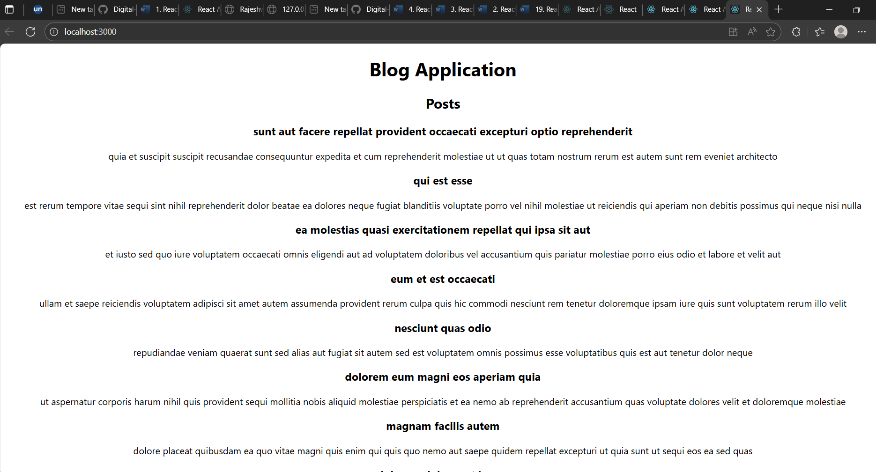

**5.ReactJS-HOL**

**Cohortdetails.js**

import React from 'react';

import styles from './CohortDetails.module.css';

function CohortDetails(props) {

const textStyle = {

color: props.status === "ongoing" ? "green" : "blue",

};

return (

<div className={styles.box}>

<h3 style={textStyle}>{props.name}</h3>

<dl>

<dt>Cohort ID:</dt>

<dd>{props.id}</dd>

<dt>Status:</dt>

<dd>{props.status}</dd>

<dt>Mentor:</dt>

<dd>{props.mentor}</dd>

</dl>

</div>

);

}

export default CohortDetails;

**app.js**

import React from 'react';

import './App.css';

import CohortDetails from './Components/CohortDetails';

function App() {

return (

<div className="App">

<h1>Cohort Dashboard</h1>

<CohortDetails id="C101" name="React Basics" status="ongoing" mentor="Raji" />

<CohortDetails id="C102" name="Angular Pro" status="completed" mentor="Lakshmi" />

</div>

);

}

export default App;

